Generative AI Journal

Introduction
The generative AI model selected for this project is ChatGPT, an advanced language model built by OpenAI on the GPT-3.5 architecture [1][2]. Modern natural language processing models like ChatGPT are well known for their ability to produce text that is coherent and appropriate for the given situation, much like a human [2]. The selection of ChatGPT was made because of its exceptional capacity to comprehend and produce text in response to various cues [2]. This makes it an excellent choice for a variety of uses, such as communication, content production, and problem-solving [3][4][5][6].
The choice to use ChatGPT was spurred by its in-depth training on a wide range of online text, which endowed it with a substantial body of data as of the January 2022 cutoff date [7][8][9][10]. This model has proven to be adept at comprehending and reacting to complex inquiries, enabling lively and interactive engagement [2]. Its adaptability fits very well with the goals of the project as it may be used for anything from text completion to code debugging.
In the following sections of this paper, we discuss ethical considerations one must note when using ChatGPT, the approaches used, the difficulties faced, and the results obtained by using ChatGPT within the parameters of the given project.

Ethical Considerations

Misinformation, Privacy, and Security: Since ChatGPT can produce writing that seems human, there are privacy and security risks as private user information might be accidentally shared or utilized improperly [11][12][13]. Moreover, ChatGPT may be used to produce deepfakes or other false material, escalating worries about the veracity and integrity of digital content [11][12][13]. Strong data protection policies and procedures are needed to address these issues and stop technology abuse [11][12][13].
ChatGPT 3.5 emphasizes a dedication to protecting data privacy and security by using careful design principles [11][12][13]. Strict procedures have been put in place by OpenAI to reduce the dangers of illegal access and possible data breaches [11][12][13]. User interactions with ChatGPT are carefully anonymised, with all personally identifiable information carefully deleted, even while the model is trained on a wide corpus of online language [11][12][13]. OpenAI has a code of ethics and is always improving the model to make it more in line with current privacy best practices [11][12][13]. This guarantee emphasizes how comfortable users are interacting with ChatGPT and how much they value the strong security measures in place to protect the privacy and security of their communications with the model [11][12][13][14].
Incident and Regulatory Response: Notably, in March 2023, Italy’s data protection regulator, the Italian Data Protection Authority, GPDP, banned ChatGPT and launched an investigation [15]. This was following an issue when ChatGPT was shut down for a while due to a bug that allowed users to see other users' chat history and conversations.
Bias:
Cultural and Linguistic Bias: ChatGPT may be biased toward particular cultures, languages, or viewpoints that are more frequently expressed online because it was trained mostly on data from the internet [16][17]. As a result, the information that the AI model produces may not fairly represent the variety of human experiences or linguistic expressions [16][17].
Gender and Racial Bias: Due to biases in the training data, ChatGPT may unintentionally reinforce racial and gender prejudices [17][18]. For instance, the model might reinforce preexisting preconceptions by linking particular occupations or professions to particular genders or ethnicities [17][18].
Bias in information Recommendations: ChatGPT may display biases in recommendation systems by giving preference to information that conforms to a user's preexisting beliefs or preferences [19][20][21]. This could lead to polarization and filter bubbles [21].

Methodology
The incorporation of the ChatGPT AI model, into this project primarily played a role in focusing on tasks such, as debugging explaining errors and gathering information. The techniques utilized were designed to make the most of ChatGPT's natural language processing abilities to enhance the results of the project.
1. Debugging and Error Explanation:
ChatGPT played a part in the debugging process by helping to identify and understand errors, in the project. By using prompts related to error messages or unexpected behaviours the system generated responses that offered insights, into potential issues. This made the debugging process more efficient. Helped resolve coding problems quickly.

2. Information Retrieval and Foundation Building:
The model was used to gather information, about the project's area. By creating prompts that asked for explanations or definitions ChatGPT helped develop a comprehension of concepts. This process of retrieving information went beyond programming questions. Included broader contextual inquiries that were pertinent, to the project goals.

3. Textual Review and Documentation Enhancement:
Notably, the documentation for the project was crafted before the intervention of generative AI. ChatGPT was then utilized to enhance the text, ensuring a meticulous review process that minimized the chance of overlooking any aspect. The model's ability to offer suggestions to improve language and enhance coherence was utilized to improve the quality of the documentation.

While the main focus wasn't on generating content or coming up with ideas, working with ChatGPT in a manner allowing for continuous enhancements, in project-related outputs. By integrating the model into the debugging and information retrieval stages and utilizing it for reviewing documentation the project team leveraged AI's generative power to boost efficiency, knowledge acquisition and overall project material quality.

Prompts and Responses
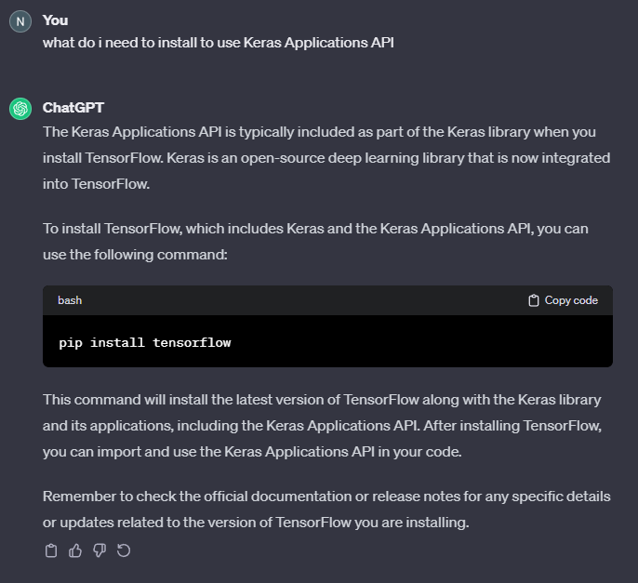
In this section we list the prompts that were used in ChatGPT. In this section we will provide the responses generated by the AI and will discuss how they helped improve the project. Each prompt and its corresponding response will highlight the collaboration, between input and AI contributions. These prompts played a role, in debugging, gathering information and refining the project.
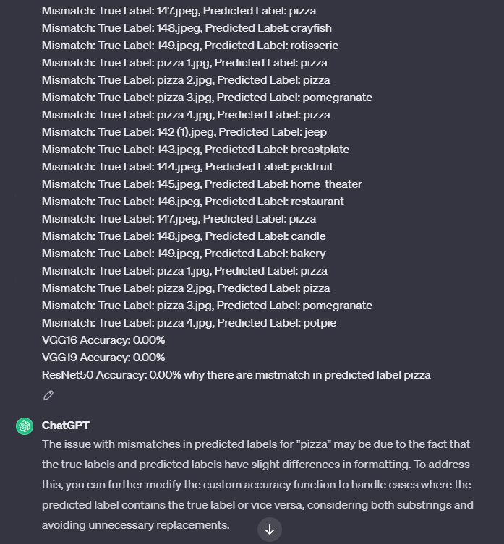
This was the first prompt, to see what is needed to be installed to uses the Keras Applications API. This response expedited the research process by not only specifying the library needed but how to install it.
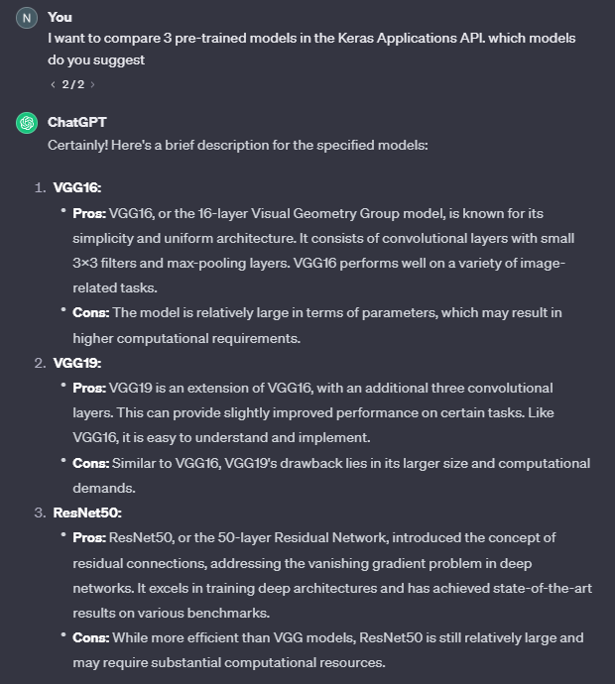
This was another prompt for Task 1. In this prompt the AI was asked about an unexpected output, the Predicted Label was correct, but it was still identified as a mismatch. The AI suggested that the True Label might not be initialised as “pizza”, which was right. Therefore, was very helpful in fixing the logical error in my code.

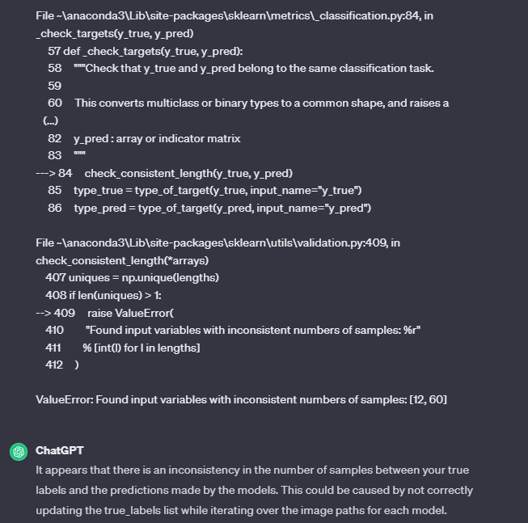
For this next prompt, the AI was asked to suggest 3 pre-trained models from the Keras Applications API. This was helpful in identifying the 3 best pre-trained models and gave a short description of all models.

For this prompt, the run time error was pasted in ChatGPT, it explained the error and suggested was needs to be charged. This helped in solving this error.

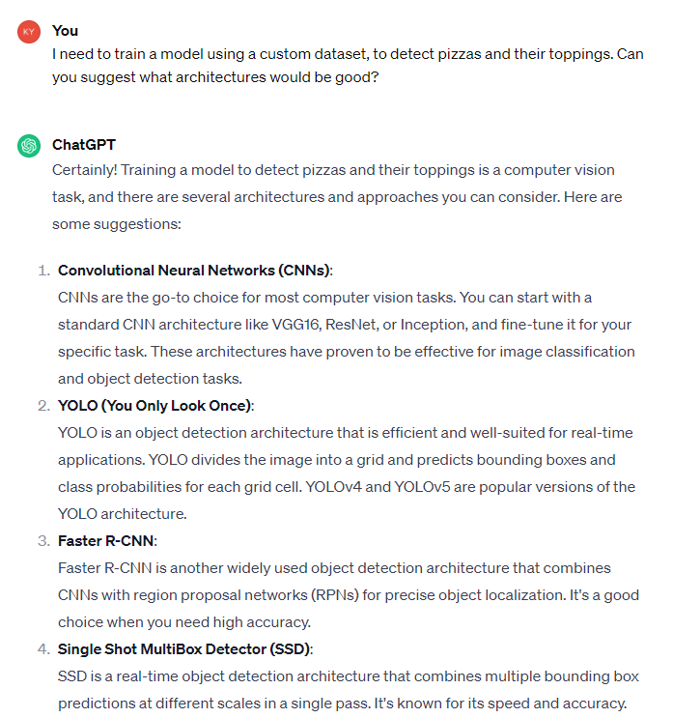
This prompt was regarding Task 3, ChatGPT was prompted to suggest what architecture should be used for the project’s purpose. ChatGPT gave valuable information on 4 architectures that expedited the research process.
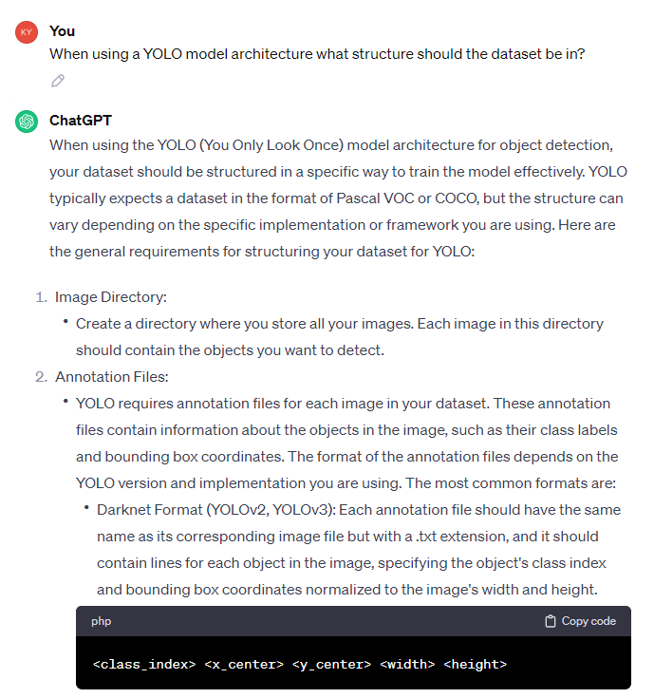

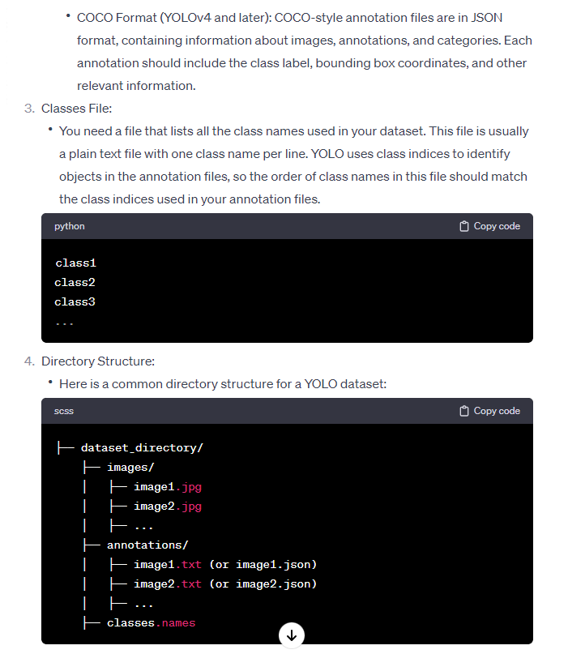
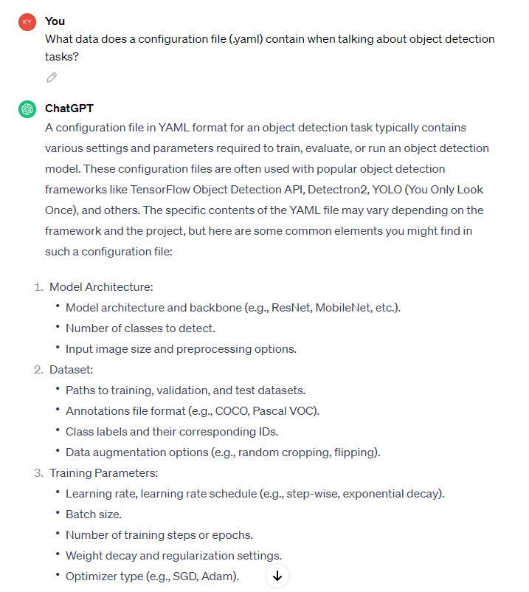
For this prompt, ChatGPT was asked for the correct structure the dataset should be when using the YOLO model architecture. This was helpful as the suggested structure was implemented and now it is working.
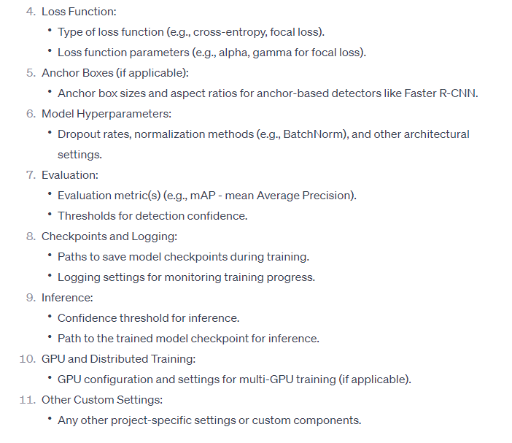
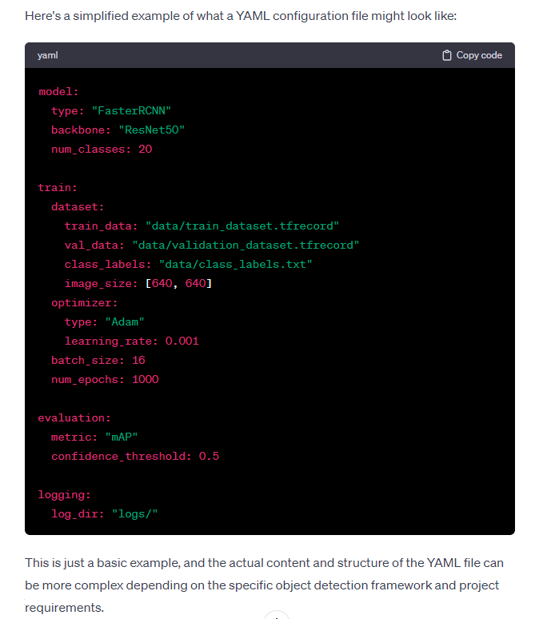
This prompt was about the data configuration file. ChatGPT gave an informative response that helped in structuring the code.

These are some of the useful prompts and responses used in this project.

Improvements and Contributions
The implementation of ChatGPT, in the project resulted in contributions improving aspects of the work. In this section, we will explore the areas where generative AI played a role, in enhancing project outcomes.
5.1. Debugging Precision and Efficiency:
ChatGPT has greatly improved the process of debugging by providing insights, into identified errors. By asking questions, about error messages or unexpected behaviours the model offered detailed explanations that helped quickly resolve coding issues. This not only expedited the debugging phase but also bolstered the overall efficiency of the development cycle.

5.2. Comprehensive Knowledge Acquisition and Tool Recommendations:
ChatGPT showcased its expertise in providing, in-depth insights in the quest for information. It proved instrumental in identifying the pre-trained models offered within the Keras Applications API streamlining the process of selecting a most suitable models that should be used for comparison (In task 1). Additionally, it went a step further by offering recommendations on libraries and guidance, on installation procedures thereby aiding the decision-making process of the project team. This wealth of knowledge extended beyond programming queries. Encompassed broader contextual inquiries aligned with the project objectives.

5.3. Textual Refinement and Documentation Enhancement:
The use of ChatGPT, in the documentation stage demonstrated its capability to enhance the quality of written materials. Even though the documentation was initially created without the assistance of AI, ChatGPT played a role in reviewing and giving advice on how to refine the text. The model's capacity to propose enhancements polishes the language. Improve coherence greatly enhanced the quality of the documentation. This iterative approach highlighted how valuable the model is, in tuning project outputs.

Individual Reflection
My interaction, with AI especially using ChatGPT in this project has been a transformative experience that has significantly impacted my understanding of how AI contributes to academic pursuits.

One of the aspects of integrating generative AI was observing its ability to speed up the process of identifying and resolving errors. ChatGPTs assistance, in recognizing and interpreting coding issues was invaluable. The model's aptitude for comprehending prompts related to programming problems provided insights, which ultimately expedited the resolution of challenges. This enhanced efficiency did not only save time but also improved the overall development workflow.

During the documentation phase, we utilized ChatGPT to refine the text and observed how it significantly improved the quality of the content. The iterative process of leveraging the model to enhance language, coherence and overall document structure showcased its potential to elevate written materials. Collaborating with AI augmentation we were able to produce documentation that not only met but exceeded our projects standards.

After my experience with ChatGPT, my perspective on integrating AI into academic projects underwent a significant transformation. I no longer see it simply as a means to automate tasks, but as an interactive partner that can elevate various elements of the project process. The insights gleaned from this encounter have sparked a deep interest in delving into the potential of generative AI for academic research. With the continuous advancement of AI, the possibilities for innovative use in academic inquiry are endless.

References and List of Resources Used
[1] OpenGenus IQ, “GPT-3.5 model architecture,” 2024. [Online]. Available: https://iq.opengenus.org/gpt-3-5-model/.
[2] OpenAI, “Introducing ChatGPT,” 2024. [Online]. Available: https://openai.com/blog/chatgpt/.
[3] AIMultiple, “50 ChatGPT Use Cases with Real-Life Examples in 2024,” 2024. [Online]. Available: https://research.aimultiple.com/chatgpt-use-cases/.
[4] Interesting Engineering, “ChatGPT: 30 incredible ways to use the AI-powered chatbot,” 2024. [Online]. Available: https://interestingengineering.com/lists/chatgpt-30-incredible-ways-to-use.
[5] MUO, “16 Things You Can Do With ChatGPT,” 2024. [Online]. Available: https://www.makeuseof.com/things-you-can-do-with-chatgpt/.
[6] Upwork, “How To Use ChatGPT: A Beginner’s Guide,” 2024. [Online]. Available: https://www.upwork.com/resources/how-to-use-chatgpt.
[7] GPT Blogs, “ChatGPT: How Much Data Is Used in the Training Process?,” 2024. [Online]. Available: https://gptblogs.com/chatgpt-how-much-data-is-used-in-the-training-process.
[8] Ars Technica, “You can now train ChatGPT on your own documents via API,” 2023. [Online]. Available: https://arstechnica.com/information-technology/2023/08/you-can-now-train-chatgpt-on-your-own-documents-via-api/.
[9] Writesonic, “How To Train ChatGPT On Your Data & Build Custom AI Chatbot,” 2024. [Online]. Available: https://writesonic.com/blog/how-to-train-chatgpt-own-data.
[10] ZeroShotDataAug, “Generating and Augmenting Training Data with ChatGPT,” 2024. [Online]. Available: https://arxiv.org/abs/2304.14334.
[11] Harvard Business Review, “The New Risks ChatGPT Poses to Cybersecurity,” 2023. [Online]. Available: https://hbr.org/2023/04/the-new-risks-chatgpt-poses-to-cybersecurity.
[12] arXiv.org, “Unveiling Security, Privacy, and Ethical Concerns of ChatGPT,” 2023. [Online]. Available: https://arxiv.org/pdf/2307.14192.pdf.

[13] Proofpoint, “What Is ChatGPT - How it Works & Security Risks,” 2024. [Online]. Available: https://www.proofpoint.com/us/threat-reference/chatgpt.
[14] Tech.co, “Does ChatGPT Save My Data? OpenAI’s Privacy Policy Explained,” 2024. [Online]. Available: https://tech.co/news/does-chatgpt-save-my-data.
[15] The Regulatory Review, “Chatting About ChatGPT Regulation,” 2023. [Online]. Available: https://www.theregreview.org/2023/11/08/yin-chatting-about-chatgpt-regulation.
[16] Cado Security, “Experimenting with ChatGPT for Incident Response,” 2024. [Online]. Available: https://www.cadosecurity.com/experimenting-with-chatgpt-for-incident-response.
[17] Medium, “The Hidden Cultural Bias of ChatGPT: Would It Be Your Friend?,” 2024. [Online]. Available: https://medium.com/@diceinrete/the-hidden-cultural-bias-of-chatgpt-would-it-be-your-friend-fe550651ede5.
[18] Axios, “The English-first bias of ChatGPT and similar AI services is a growing …,” 2023. [Online]. Available: https://www.axios.com/2023/09/08/ai-language-gap-chatgpt.
[19] medRxiv, “ChatGPT Exhibits Gender and Racial Biases in Acute Coronary Syndrome …,” 2023. [Online]. Available: https://www.medrxiv.org/content/10.1101/2023.11.14.23298525v1.
[20] “ChatGPT perpetuates racial and gender biases,” AuntMinnie. [Online]. Available: https://www.auntminnie.com/imaging-informatics/artificial-intelligence/article/15660882/chatgpt-perpetuates-racial-and-gender-biases.
[21] “Uncovering The Different Types Of ChatGPT Bias,” Forbes. [Online]. Available: https://www.forbes.com/sites/forbestechcouncil/2023/03/31/uncovering-the-different-types-of-chatgpt-bias/.

